Temperature Monitoring
Temperature monitoring enhances reliability as well as allowing the efficiency of a close approach to maximum performance. It can also serve to protect the system against overheating if the cooling system fails completely or deteriorates to the point of inadequacy.
Silicon sensors are becoming increasingly important as temperature transducers in electronic systems because they are linear, accurate, cheap, reliable; and can be incorporated on the same IC as other analog or digital functions. They take advantage of the relationship between base-emitter voltage (V_{BE}) and current density (current/emitter area) in silicon bipolar junction transistors to generate a voltage proportional to absolute temperature (PTAT). If currents in a fixed ratio, r, flow through two identical transistors (or if equal currents flow through one transistor and a set of r identical paralleled transistors) the differential V_{BE} is PTAT. Figure 4 is a circuit that illustrates the principle. A₁ and A₂ are emitter areas, I_{S} is reverse saturation current, and k/q is the ratio of Boltzmann's constant to electron charge, about 86 µV/K.

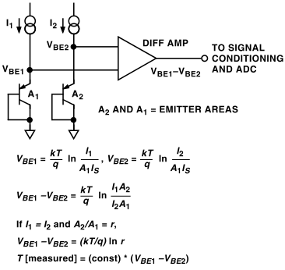
Figure 4. How a silicon temperature sensor works

